Analysis of Virtual and Extended Realities

By Andrew Phillip Gonzalez

Extended Realities in Games and Alternate Industries

General description

* AR use in mobile games can be seen in games like PokemonGO, Minecraft EARTH, Jurassic Park Alive to name a few. (images needed)
  + In these games, the game world is overlayed with the world through the camera of the phone to give the impression that both realities are merged.[1]
* VR has had a meaningful impact in the Architectural and Defence Industry.
  + Allowing prospective clients to experience a building before it is built and see its structure, and interiors.
  + Creating trust between architects and clients by through virtual visualization.

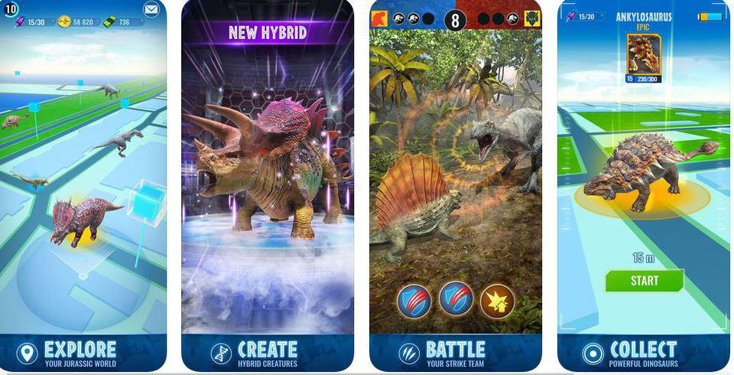

Figure 1 - Jurassic World Alive, Mobile AR Game

Physiological Constraints

* Oculus
  + Current Oculus Quest 2 has a setting whereby the user can set the

HUD and UI function in Extended Realities

* Virtual Reality games
  + The design and approaches to UI and HUD is very different in design approach, having to consider the user’s sense of balance and motion.

Use of Haptic feedback in Extended Realities

* There is not a lot of haptic feedback integrated on a commercial level, or at least to an affordable level for the common market.

1. https://en.wikipedia.org/wiki/Augmented_reality#Reality_modifications